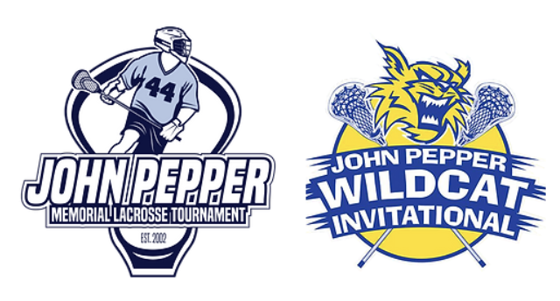

**2024 John Pepper Tournaments Release Of Liability**

**For ALL Grade Levels & Participants**

As a parent/guardian of a participant in the John Pepper Wildcat Invitational and the John Pepper Memorial Youth Tournament my child/ward being allowed to participate in these tournaments, it is understood and agree that:

1) There is the possibility of injury to my child/ward from the activities involved with the tournament, and while particular rules, equipment, and personal discipline may limit the potential for injuries, nonetheless the risk exists.

2) As a parent/guardian of a participant, I FOR MYSELF, SPOUSE AND CHILD/WARD. KNOWINGLY AND FREELY ASSUME ALL SUCH RISKS, both known and unknown, EVEN IF ARISING FROM THE NEGLIGENCE OF THE RELEASEES or others, and assume full responsibility for my child/ward’s participation; and,

3) As a parent/guardian of a participant, I willingly agree to comply with the tournament!s terms and conditions for participation. If I observe any unusual concerns regarding my child/ward!s readiness for participation and/or the tournament itself, I will remove my child/ward from the competition and bring such attention to the tournament officials immediately; and,

4) As a parent/guardian of a participant for myself, my spouse, my child/ward, and on behalf of my/our heirs, assigns, personal representatives and next of kin, HEREBY RELEASE AND HOLD HARMLESS **the JOHN PEPPER MEMORIAL ATHLETIC FUND,INC** and its directors, officers, field officials, agents, employees, volunteers, other participants, sponsoring agencies, sponsors, advertisers, and if applicable, owners and lessors of premises used to conduct the event ("Releasees”), WITH RESPECT TO ANY AND ALL INJURY, DISABILITY, DEATH, or loss of damage to person or property incident to my child/ward!s involvement or participation in this tournament, WHETHER ARISING FROM THE NEGLIGENCE OF THE RELEASEES OR OTHERWISE, to the fullest extent permitted by law.

5) As a parent/guardian of a participant, for myself, my spouse, my child’s ward, and on behalf of my/our heirs, assigns, personal representatives and next of kin, HEREBY INDEMNIFY AND HOLD HARMLESS all the above Releasees from any and all liabilities incident to my child/ward!s involvement or participation in this tournament, EVEN IF ARISING FROM THEIR NEGLIGENCE, to the fullest extent permitted by law.

AS A PARENT/GUARDIAN OF A PARTICIPANT IN THE JOHN PEPPER LACROSSE TOURNAMENTS, I HAVE READ THIS RELEASE OF LIABILITY AND ASSUMPTION OF RISK AGREEMENT AND UNDERSTAND THAT THIS HAS BEEN OFFERED FOR MY REVIEW ON THE JOHN PEPPER LACROSSE WEBSITE, THE SPORTS ENGINE TOURNEY MACHINE WEBSITE AS WELL AS POSTED AT THE REGISTRATION TABLE AT THE TOURNAMENTS. I/WE FULLY UNDERSTAND ITS TERMS, AND UNDERSTAND THAT I/WE HAVE FORFEITED CERTAIN RIGHTS AND DO SO FREELY AND VOLUNTARILY WITHOUT ANY INDUCEMENT.